**Solution: Configure Drawer Navigation**

**Overview**

In this reading, you will review the solution code for the exercise.

The code block below outlines the outcome of the exercise in its entirety.  All the other code is available in the starter code for this exercise.

***App.js***

1

2

3

4

5

6

7

8

9

10

11

12

13

14

15

16

17

18

19

20

21

22

23

24

25

26

27

28

29

30

31

32

33

34

35

36

import { View, StyleSheet } from 'react-native';

import LittleLemonHeader from './components/LittleLemonHeader';

import LittleLemonFooter from './components/LittleLemonFooter';

import WelcomeScreen from './WelcomeScreen';

import LoginScreen from './LoginScreen';

import { NavigationContainer } from '@react-navigation/native';

import { createDrawerNavigator } from '@react-navigation/drawer';

const Drawer = createDrawerNavigator();

export default function App() {

  return (

    <>

      <NavigationContainer>

        <View style={styles.container}>

          <LittleLemonHeader />

          <Drawer.Navigator useLegacyImplementation initialRouteName="Login">

            <Drawer.Screen name="Welcome" component={WelcomeScreen} />

            <Drawer.Screen name="Login" component={LoginScreen} />

          </Drawer.Navigator>

        </View>

        <View style={styles.footerContainer}>

          <LittleLemonFooter />

        </View>

      </NavigationContainer>

    </>

  );

}

const styles = StyleSheet.create({

  container: {

    flex: 1,

    backgroundColor: '#333333',

  },

  footerContainer: { backgroundColor: '#333333' },

});

The code above would look like the following on the emulator:

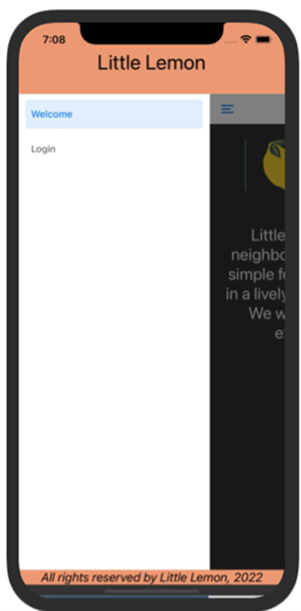

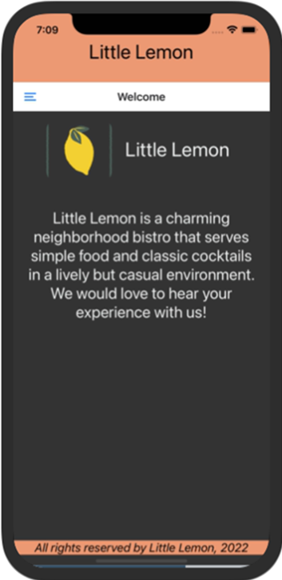

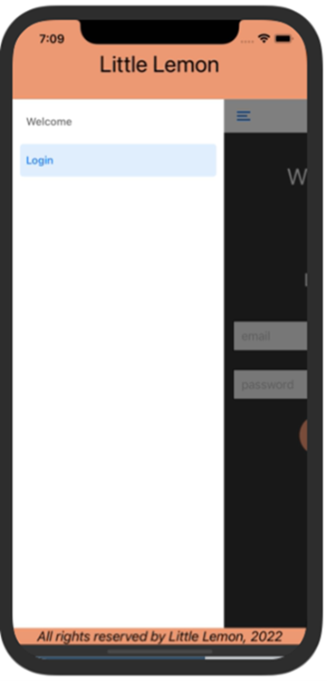

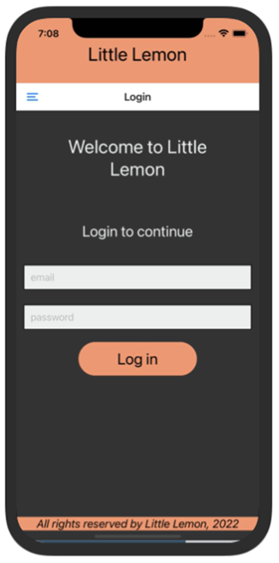

**Procedure**

Next, review the breakdown of the individual steps below.

**Step 1: Install Drawer navigation**

Your first step is to ensure that the dependencies are installed correctly. Once your dependencies are installed, the **package.json** file should contain the following:

1

2

3

4

5

6

7

8

9

10

11

12

13

14

15

{

 "dependencies": {

    "@expo/vector-icons": "^13.0.0",

    "@react-native-community/masked-view": "*",

    "react-native-gesture-handler": "~2.5.0",

    "react-native-pager-view": "5.4.24",

    "react-native-paper": "^4.7.2",

    "react-native-reanimated": "~2.9.1",

    "react-native-safe-area-context": "4.3.1",

    "react-native-screens": "~3.15.0",

    "@react-navigation/drawer": "6.4.1",

    "@react-navigation/native": "6.0.0"

  }

}

**Step 2: Instantiate createDrawerNavigator**

Next, include the necessary imports and instantiate the drawer navigator in your **App.js** file as follows:

1

2

3

4

5

import { createDrawerNavigator } from '@react-navigation/drawer';

const Drawer = createDrawerNavigator();

**Step 3: Setup Drawer Navigator and Drawer Screens with routes**

With all the initial work done, your final step is to set up the routes within the drawer as follows. You can also provide a default route to start with, which in this case, it is the **Login** screen.

And there, you've just set up routes!

1

2

3

4

5

6

7

8

9

10

11

12

13

14

15

16

17

18

19

20

 const Drawer = createDrawerNavigator();

export default function App() {

  return (

    <>

      <NavigationContainer>

        <View style={styles.container}>

          <LittleLemonHeader />

          <Drawer.Navigator useLegacyImplementation initialRouteName="Login">

            <Drawer.Screen name="Welcome" component={WelcomeScreen} />

            <Drawer.Screen name="Login" component={LoginScreen} />

          </Drawer.Navigator>

        </View>

        <View style={styles.footerContainer}>

          <LittleLemonFooter />

        </View>

      </NavigationContainer>

    </>

  );

}